Laravel & React JS Basics Documentation

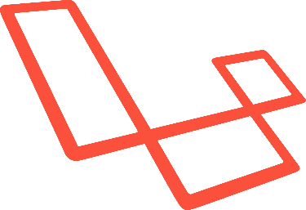

Table of Contents

**1.0** **INSTALLATION PROCESS** 3

1.1 Composer 3

1.2 Laravel 4

1.3 Install React 5

**2.0 CSS & JAVASCRIPT LINKAGE** 6

# **INSTALLATION PROCESS**

## 1.1 Composer

* Click on the setup given in the folder and install composer
* Select Developer Mode

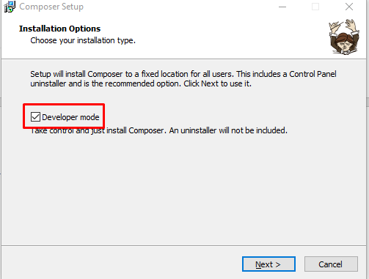

* Ensure that the path is in C:/composer

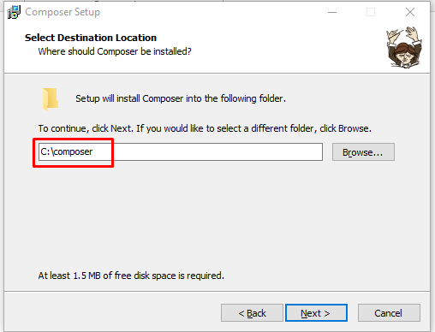

* 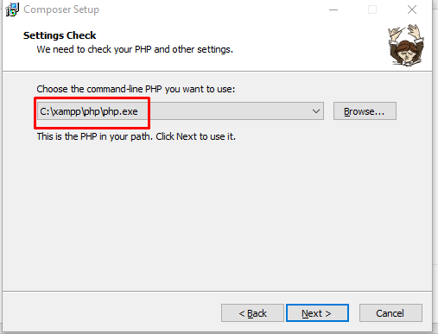If you have Xampp installed on your computer, ensure that this path corresponds as follows:
* Ignore the proxy settings and click on next, then install

## 1.2 Laravel

* Create a folder in your c://xampp/htdocs directory
* Open that folder directory in CMD by typing cmd in the folder explorer bar
* Then type the following command:
  + **composer create-project --prefer-dist laravel/laravel YourProjectName**
    - e.g. composer create-project --prefer-dist laravel/laravel myFirstProject
* Wait until installation is successful
* After installation completed, Open the project created through cmd and type the following command:
  + **php artisan serve**
    - You will receive a link, open it as it will enable the launching of the project in your browser. And voila you are good to go.

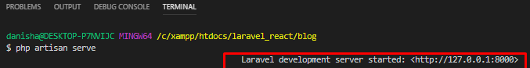

## 1.3 Install React

* To Install React, Open your project in cmd and type the following:
  + **php artisan preset react**
* Then type npm install
* Then type npm run dev

**\*\*\*That’s all you need for the installing process\*\*\***

# **2.0 CSS & JAVASCRIPT LINKAGE**

Steps:

1. Open your project and open **resources\views\welcome.blade.php**
2. Remove everything in the <body> tag
3. Remove the <style> tag
4. CSS linking => Add **<link href="/css/app.css" rel="stylesheet" />** in your <head> tag
5. JS linking => Add **<script src="/js/app.js"></script>**

# DATABASE & MIGRATION

Steps:

1. Open phpmyadmin and create a new database
2. Open .env file and modify as follows:

DB_CONNECTION=mysql

DB_HOST=127.0.0.1

DB_PORT=3306

DB_DATABASE=yourDatabaseName

DB_USERNAME=root

DB_PASSWORD=

1. Then, type in cmd
   1. **php artisan migrate**
      1. This will create 2 tables (migration and users) in phpmyadmin given by laravel by default.
2. To create a new table in your database,
   1. First create a migration file
      1. **php artisan make:migration create_nameOFtable**

The migration file will be automatically created under database\migrations section

1. Once migration file has been created, open it and add your fields in it.

List of Laravel datatype ==> https://www.tkserver.com/laravel-database-column-types/

1. After setting the table's fields,
   1. Type php artisan migrate in your cmd in order to push it to your database

3.0 React Component

4.0 React Router

5.0 Mode & Controller for RESTFUL API

1. Create Model

* Open cmd and type the following:

**php artisan make:model Mode/nameOfYourModel**

* Note: Ensure that your model name is in singular
* Model are automatically created under directory app/
* The Model/ puts it in a folder for you
* Open your Model

1. Create Controller

* Open cmd and type the following:

**php artisan make:controller myControllers/nameOfYourController --resource**

* The myControllers/ puts it in a folder for you
* Controllers are located under \app\Http\Controllers

1. Linking Model and Controller

Now that model and controller has been created, we need to link them.

Open the controller and add the following line of code to the top of your code:

**use App\Model\nameOfYourModel;**

**E.g. use App\Model\Category;**

Next, Open your controller and locate the function index and add the following:

public function index(){

$result = Category::all(); // Fetch all data from the model Category

return $result;

}

This function is the default function.

**THE LISTING COMPONENT (GET) (READ)**

1. Route Controller with View (E.g. Listing Component)

Route::get('category/Listing','myControllersApi\CategoryController@index');

1. View (Listing Component)

* Import package axios // used to handle HTTP request

import axios from "axios";

* Create a constructor function

constructor() {

super();

this.state = {

categories: [] //empty array

};

}

* Get Response

componentDidMount() {

axios.get("http://127.0.0.1:8000/category/Listing").then(response =>{ //

this.setState({ categories: response.data }); // get response

});

}

* Display Data in table

<tbody>

{this.state.categories.map(c => { // LOOP THOUGH ARRAY categories

return (

<tr>

<td>{c.category_name}</td> //display fields from db

<td>{c.category_type}</td>

<td>

{c.active == 1 ? "Active" : "Inactive"}

</td>

</tr>

);

})}

</tbody>

**THE ADD COMPONENT (POST)(CREATE)**